IMAT2207 Agile Team Development
Practical – Unit 8

Building Your Allocated Component
Creating the Find Method

Creating the Methods 1
Before you Begin 1
The Find Method 1
Read me first - a Quick Overview 1
Create a Fresh Branch 2
Creating the testing 2
Hard Coded Data Layer 4
What you need to do 6
Merge the Branch to the Master 17
Creating the Data Layer 17
Start your Git Hub day 17
Quick Recap 17
Modifying the Find Function 18
Connecting to the Database 19
The clsDataConnection Class 19
SQL Connect 20
Connection Strings and Public Git Repositories 20
SQL Server Databases 21
Local Databases 22
Creating the Test Record 23
What you need to do 23
Finishing the Find Method 24
Adding the Find Button to the Presentation Layer 24
What you need to do 26
Questions 26
Merge the Branch to the Master 26

Creating the Methods

Before you Begin
Make sure that you have completed the work for last week and that you have watched the eLectures for this week before starting this work.

The Find Method
Having created the properties of clsAddress we now need to think about how to approach building the methods for the class.
There are two methods in the class; Find and Valid.
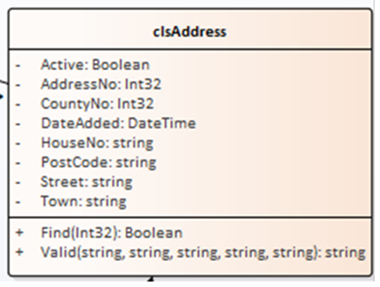
Let’s have a go at Find first.

Read me first - a Quick Overview
We need to think a little about how this method is going to work.
Let’s assume that the table in the database contains the following data…
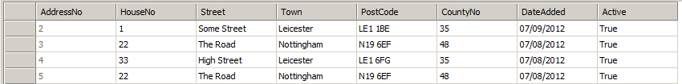

How the method works is that we will always send it the value of a record’s primary key we want to find e.g. 2.
If record 2 is found the method will return a value of true. If it doesn’t it will return false.
As well as returning true or false the method also needs to return the data for all fields of the record being searched for.
For example:
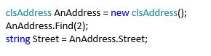
We would set the value of the variable Street to “Some Street”.
What we will eventually do is set up some test data in the table that will be used to check that the method is returning the data we think it should be.

Create a Fresh Branch
Remember, this is a new Git Hub working day. You need to make sure you have completed the previous work to perfection and closed any existing branches.
As per usual you will need to create a blank folder and clone a fresh copy of the master to the folder.
Remember to create a new branch to complete this work.

Creating the testing
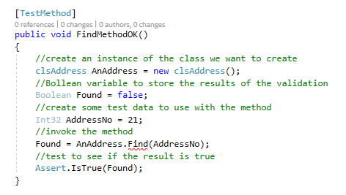
Let’s start with the simple things first. We need to create a test to ensure the existence of the method.

We’ll add this new test to our class under the other tests for the properties. (In my case tstAddress.) Like so…
‘Find’ should be underlined in red as shown...

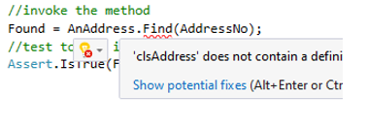
Run the test and watch it fail. We need to fix it by creating the method.
Remember, hold the mouse over the failing test…
Next click, show potential fixes…

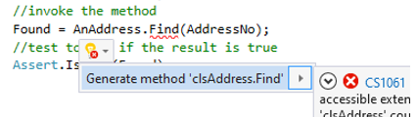
Select ‘Generate method...’

Run the tests again and it should still fail due to the code in the class not being right.
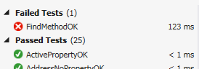
One of the features of Test Driven Development (TDD) is that we can put in a quick fix to problems by simply making them pass the test pass.
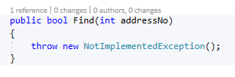
Look in the class clsAddress at the auto generated code…
By design, the new method is set up to throw an exception.

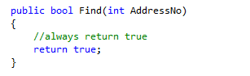
We can change the auto generated code such that the test passes. This makes the test pass, but it clearly isn’t the final code.
When we run the test, it should now pass.
Modifying the Find method on clsAddress to always return true forces the test to pass but doesn’t exactly fix the problem in the long term.

Hard Coded Data Layer
Before we add any data to the database, we will start by hard coding the data layer to simulate the data being accessed.
We need to create a series of tests that search for the record and ensure that the correct data is being returned.
The first test in tstAddress is as follows…
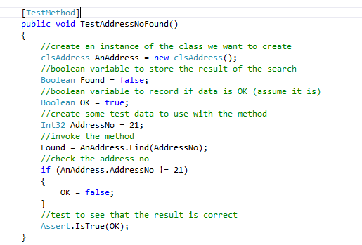
This test finds record number 21 and checks to see if the AddressNo property is also set to 21.
As usual the test should fail…
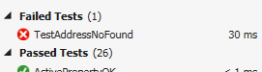
Let’s fix the problem to see if we can resolve the failed test.
To make this work we need to make some modifications to the class clsAddress.

Firstly, we need to create a private data member for the public property…
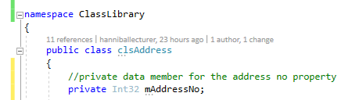
Next, we need to change the structure of the public property from this…

To this…
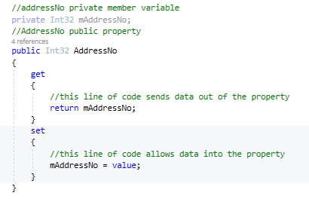
What we’ve one is create a private member variable and a getter and setter.
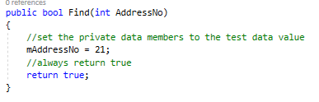
Next, we need to modify the Find method to set the private data member so that it can be returned via the public property…
This code is basically rubbish because:
- It can only ever search for record number 21
- It is not drawing any data from the database
but it allows us to write our testing.
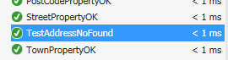
Let’s try the running the test again…
The good news is that it passes. The bad news is that the fix is still a bit rubbish, but we don’t care about that for now!

What you need to do
You will now need to create similar tests for each attribute in your class.
You’ll need to add private data members and modify the public properties as you go.
For example, here is the next test but this time for DateAdded…
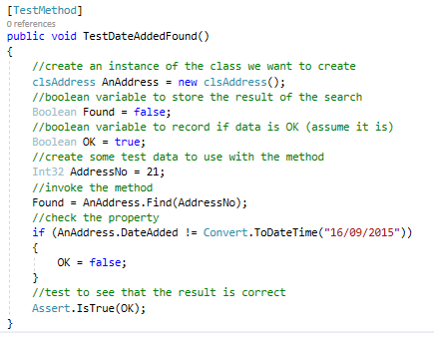
This test looks for record 21 and tests to see that it has a date of “16/09/2015”
You will need to modify the Find function to provide the simulated data…
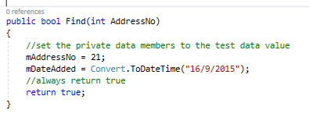
You will also need to modify the existing property to include a private member variable and a getter and setter. For example…
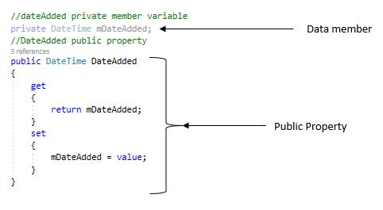
You will need to do this for each attribute in your class. Here is the full version of the AddressBook testing code including code from last week at the top…
using System;
using Microsoft.VisualStudio.TestTools.UnitTesting;
using Class_Library;

namespace Test_Framework
{
[TestClass]
public class tstAddress
{
[TestMethod]
public void InstanceOK()
{
//create an instance of the class we want to create
clsAddress AnAddress = new clsAddress();
//test to see that it exists
Assert.IsNotNull(AnAddress);
}

[TestMethod]
public void ActivePropertyOK()
{
//create an instance of the class we want to create
clsAddress AnAddress = new clsAddress();
//create some test data to assign to the property
Boolean TestData = true;
//assign the data to the property
AnAddress.Active = TestData;
//test to see that the two values are the same
Assert.AreEqual(AnAddress.Active, TestData);
}

[TestMethod]
public void DateAddedPropertyOK()
{
//create an instance of the class we want to create
clsAddress AnAddress = new clsAddress();
//create some test data to assign to the property
DateTime TestData = DateTime.Now.Date;
//assign the data to the property
AnAddress.DateAdded = TestData;
//test to see that the two values are the same
Assert.AreEqual(AnAddress.DateAdded, TestData);
}

[TestMethod]
public void AddressNoPropertyOK()
{
//create an instance of the class we want to create
clsAddress AnAddress = new clsAddress();
//create some test data to assign to the property
Int32 TestData = 1;
//assign the data to the property
AnAddress.AddressNo = TestData;
//test to see that the two values are the same
Assert.AreEqual(AnAddress.AddressNo, TestData);
}

[TestMethod]
public void CountyNoPropertyOK()
{
//create an instance of the class we want to create
clsAddress AnAddress = new clsAddress();
//create some test data to assign to the property
Int32 TestData = 1;
//assign the data to the property
AnAddress.CountyNo = TestData;
//test to see that the two values are the same
Assert.AreEqual(AnAddress.CountyNo, TestData);
}

[TestMethod]
public void HouseNoPropertyOK()
{
//create an instance of the class we want to create
clsAddress AnAddress = new clsAddress();
//create some test data to assign to the property
string TestData = "21b";
//assign the data to the property
AnAddress.HouseNo = TestData;
//test to see that the two values are the same
Assert.AreEqual(AnAddress.HouseNo, TestData);
}

[TestMethod]
public void PostCodePropertyOK()
{
//create an instance of the class we want to create
clsAddress AnAddress = new clsAddress();
//create some test data to assign to the property
string TestData = "LE1 4AB";
//assign the data to the property
AnAddress.PostCode = TestData;
//test to see that the two values are the same
Assert.AreEqual(AnAddress.PostCode, TestData);
}

[TestMethod]
public void StreetPropertyOK()
{
//create an instance of the class we want to create
clsAddress AnAddress = new clsAddress();
//create some test data to assign to the property
string TestData = "Some Street";
//assign the data to the property
AnAddress.Street = TestData;
//test to see that the two values are the same
Assert.AreEqual(AnAddress.Street, TestData);
}

[TestMethod]
public void TownPropertyOK()
{
//create an instance of the class we want to create
clsAddress AnAddress = new clsAddress();
//create some test data to assign to the property
string TestData = "Leicester";
//assign the data to the property
AnAddress.Town = TestData;
//test to see that the two values are the same
Assert.AreEqual(AnAddress.Town, TestData);
}

NEW CODE FROM HERE
[TestMethod]
public void FindMethodOK()
{
//create an instance of the class we want to create
clsAddress AnAddress = new clsAddress();
//boolean variable to store the result of the validation
Boolean Found = false;
//create some test data to use with the method
Int32 AddressNo = 1;
//invoke the method
Found = AnAddress.Find(AddressNo);
//test to see that the result is correct
Assert.IsTrue(Found);
}

[TestMethod]
public void TestAddressNoFound()
{
//create an instance of the class we want to create
clsAddress AnAddress = new clsAddress();
//boolean variable to store the result of the search
Boolean Found = false;
//boolean variable to record if data is OK (assume it is)
Boolean OK = true;
//create some test data to use with the method
Int32 AddressNo = 21;
//invoke the method
Found = AnAddress.Find(AddressNo);
//check the address no
if (AnAddress.AddressNo != 21)
{
OK = false;
}
//test to see that the result is correct
Assert.IsTrue(OK);
}

[TestMethod]
public void TestStreetFound()
{
//create an instance of the class we want to create
clsAddress AnAddress = new clsAddress();
//boolean variable to store the result of the search
Boolean Found = false;
//boolean variable to record if data is OK (assume it is)
Boolean OK = true;
//create some test data to use with the method
Int32 AddressNo = 21;
//invoke the method
Found = AnAddress.Find(AddressNo);
//check the property
if (AnAddress.Street != "Test Street")
{
OK = false;
}
//test to see that the result is correct
Assert.IsTrue(OK);
}

[TestMethod]
public void TestTownFound()
{
//create an instance of the class we want to create
clsAddress AnAddress = new clsAddress();
//boolean variable to store the result of the search
Boolean Found = false;
//boolean variable to record if data is OK (assume it is)
Boolean OK = true;
//create some test data to use with the method
Int32 AddressNo = 21;
//invoke the method
Found = AnAddress.Find(AddressNo);
//check the property
if (AnAddress.Town != "Test Town")
{
OK = false;
}
//test to see that the result is correct
Assert.IsTrue(OK);
}

[TestMethod]
public void TestPostCodeFound()
{
//create an instance of the class we want to create
clsAddress AnAddress = new clsAddress();
//boolean variable to store the result of the search
Boolean Found = false;
//boolean variable to record if data is OK (assume it is)
Boolean OK = true;
//create some test data to use with the method
Int32 AddressNo = 21;
//invoke the method
Found = AnAddress.Find(AddressNo);
//check the property
if (AnAddress.PostCode != "XXX XXX")
{
OK = false;
}
//test to see that the result is correct
Assert.IsTrue(OK);
}

[TestMethod]
public void TestCountyNoFound()
{
//create an instance of the class we want to create
clsAddress AnAddress = new clsAddress();
//boolean variable to store the result of the search
Boolean Found = false;
//boolean variable to record if data is OK (assume it is)
Boolean OK = true;
//create some test data to use with the method
Int32 AddressNo = 21;
//invoke the method
Found = AnAddress.Find(AddressNo);
//check the property
if (AnAddress.CountyNo != 1)
{
OK = false;
}
//test to see that the result is correct
Assert.IsTrue(OK);
}

[TestMethod]
public void TestDateAddedFound()
{
//create an instance of the class we want to create
clsAddress AnAddress = new clsAddress();
//boolean variable to store the result of the search
Boolean Found = false;
//boolean variable to record if data is OK (assume it is)
Boolean OK = true;
//create some test data to use with the method
Int32 AddressNo = 21;
//invoke the method
Found = AnAddress.Find(AddressNo);
//check the property
if (AnAddress.DateAdded !=Convert.ToDateTime("16/09/2015"))
{
OK = false;
}
//test to see that the result is correct
Assert.IsTrue(OK);
}

[TestMethod]
public void TestActiveFound()
{
//create an instance of the class we want to create
clsAddress AnAddress = new clsAddress();
//boolean variable to store the result of the search
Boolean Found = false;
//boolean variable to record if data is OK (assume it is)
Boolean OK = true;
//create some test data to use with the method
Int32 AddressNo = 21;
//invoke the method
Found = AnAddress.Find(AddressNo);
//check the property
if (AnAddress.Active != true)
{
OK = false;
}
//test to see that the result is correct
Assert.IsTrue(OK);
}
}
}

Here is the finished code as it stands for the class clsAddress:
using System;
using System.Collections.Generic;
using System.Linq;
using System.Text;

namespace Class_Library
{
public class clsAddress
{

//private data member for active
private Boolean mActive;
//public property for active
public bool Active
{
get
{
//return the private data
return mActive;
}
set
{
//set the private data
mActive = value;
}
}

//private date added data member
private DateTime mDateAdded;
//public property for date added
public DateTime DateAdded
{
get
{
//return the private data
return mDateAdded;
}
set
{
//set the private data
mDateAdded = value;
}
}

//private data member for the AddressNo property
private Int32 mAddressNo;
//public property for the address number
public int AddressNo
{
get
{
//return the private data
return mAddressNo;
}
set
{
//set the value of the private data member
mAddressNo = value;
}
}

//private data member for county no
private Int32 mCountyNo;
//public property for county no
public int CountyNo
{
get
{
//return the private data
return mCountyNo;
}
set
{
//set the private data
mCountyNo = value;
}
}

//private data member for HouseNo
private string mHouseNo;
//public property for house no
public string HouseNo
{
get
{
//return private data
return mHouseNo;
}
set
{
//set the private data
mHouseNo = value;
}
}
//private data member for post code
private string mPostCode;
//public property for post code
public string PostCode
{
get
{
//return the private data
return mPostCode;
}
set
{
//set the private data
mPostCode = value;
}
}

//private data member for street
private string mStreet;
//public data member for street
public string Street
{
get
{
//return the private data
return mStreet;
}
set
{
//set the private data
mStreet = value;
}
}

//private data member for town
private string mTown;
//public data member for Town
public string Town
{
get
{
//return the private data
return mTown;
}
set
{
//set the private data
mTown = value;
}
}
public bool Find(int AddressNo)
{
//set the private data members to the test data value
mAddressNo = 21;
mHouseNo = "123";
mStreet = "Test Street";
mTown = "Test Town";
mPostCode = "XXX XXX";
mCountyNo = 1;
mDateAdded = Convert.ToDateTime("16/9/2015");
mActive = true;
//always return true
return true;
}
}
}

Merge the Branch to the Master
At this point it might be a good idea to merge your branch to the master. As always remember only merge perfect code to the master and delete your unwanted branch.

Creating the Data Layer

Start your Git Hub day
If you’ve merged your branch back to the master create a new clone and as always start in a fresh branch.
Quick Recap
At this stage all tests should pass, however there is still one important feature that is missing.
That is, we are still not actually drawing the data from the database!
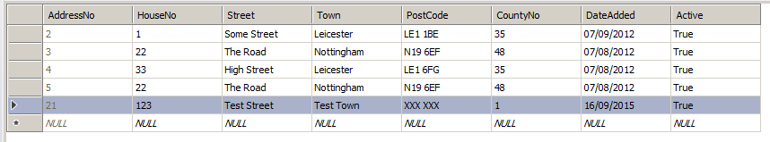
You will have created the table we need in an earlier handout…
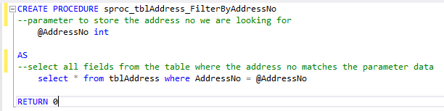
You will also need to create the following stored procedure if you haven’t already done so…
Once you have the table and stored procedure in place, I would suggest you test the stored procedure to make sure that it works as planned. Use the SQL Server Object Explorer (SQL Server DB) or the Server Explorer (if you’re using a local DB) to execute the stored procedure directly.
Make sure it is working before you move onto the next section.

Modifying the Find Function
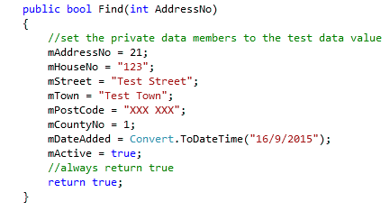

We now need to change the code for the Find method from this:

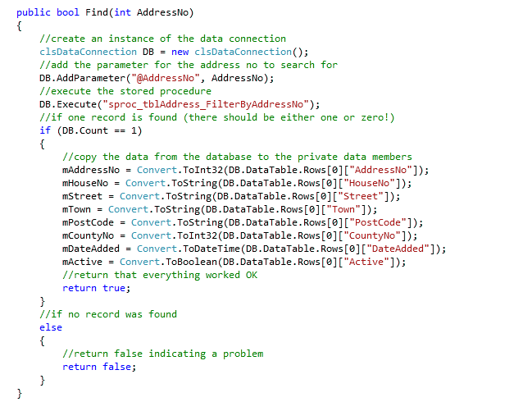

To this:

You should now see all your lovely tests fail.
So, what is the problem?
The problem is that our Find method is looking to connect to the database and we need to set up a few things to allow that to happen.

Connecting to the Database
There are several ways that we can connect to the database in this work.
The first approach is to use the online SQL Teams portal to connect to your SQL Server database. We covered this in the ‘Connecting to the Database’ handout. Alternatively, you can use a local database which we covered in the ‘Creating a Local Database Handout.
The next approach is to use Visual Studio to create tables and stored procedures. We did that in the previous handouts too.
The final tools we need are the class clsDataConnnection and SQL Connect which allow our running program to access SQL Server directly.

The clsDataConnection Class
This class has been written for you to avoid you having to deal with the complexities of working with ADO.NET the technology used by Microsoft to link to the SQL server database.
In the Class Library create a new class called clsDataConnection
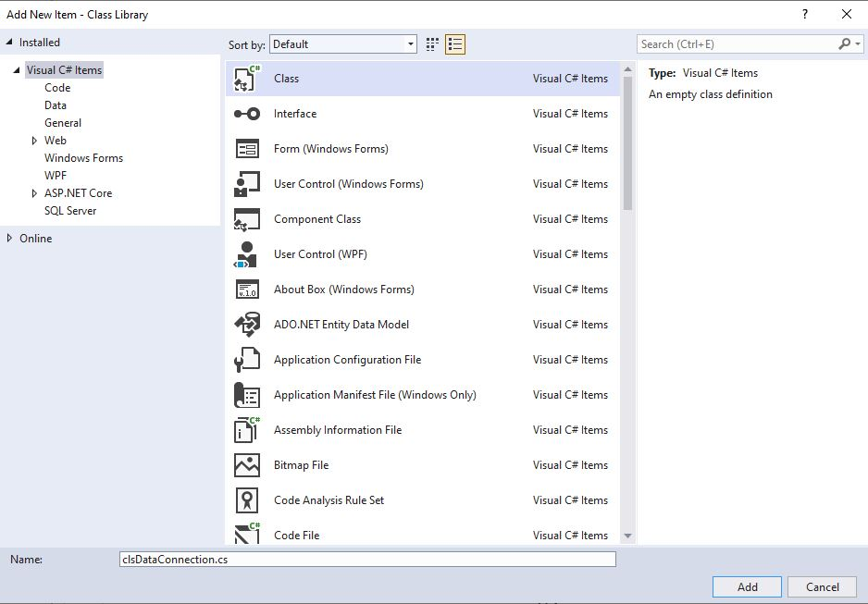
Remember to rename the class before clicking the Add button. You can rename it from the Class Library folder by right clicking the class and selecting rename.

Double click on the new clsDataConnection class so it is ready for editing. Delete any code that is auto generated. Go to the module website and open a copy of the data connection class code. Copy the entire code from the text file and paste into the clsDataConnection class. Click Save on the main menu.
Now let’s take a quick look at the updated code in the Find method. Notice how the object ‘DB’ is used to manipulate the stored procedure and access the fields in the table…

SQL Connect
The last tool we need to use is a little program called SQL Connect. For your code to connect to SQL Server we need to provide it with the name of your server, then the name of your database, your username and password.

Connection Strings and Public Git Repositories
A connection string is a string containing authentication and other settings to connect to the database.
The connection string will need to contain your username and password for the SQL server database.
So, here is the problem. If you add the connection string into your code and place it into a public repository, your plain text username and password is visible for all to see.
Even if you were using a private repository it likely still isn’t a good idea to store these details as plain text.
To get around this problem a program has been written called SQL Connect, available from the module web site.
When you run the program, you will see the following interface...
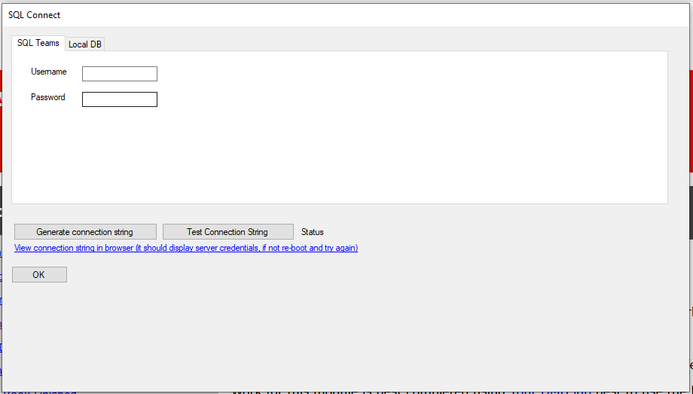
SQL Connect must be running at the same time as your program to allow your code to access the database.

If you’re using a SQL Server Database Only
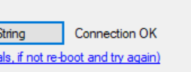
Click on the SQL Teams tab and enter your team database username and password.
Next click on the ‘Generate connection string’ button. Followed by the ‘Test Connection String’ button. If all is ok you will see the following ‘Connection OK’ message.
If there are issues, check the that your username and password are in the connection string by clicking on the link.
If you can’t see your log in details in the connection string or if you get a message saying your database is in use or something similar, disconnect from the server from the SQL Server Object Explorer by right clicking on the database and selecting ‘close connection’ and run SQL Connect again. Don’t forget to reconnect to the database in the SQL Server Object Explorer.

If you’re using a Local Database Only
For local databases click on the ‘Local DB’ tab.
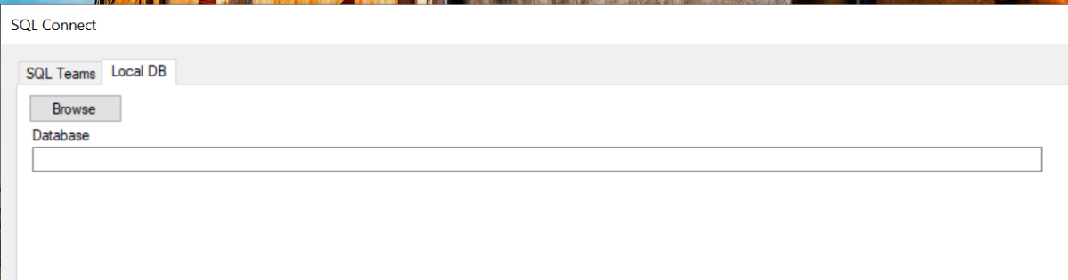
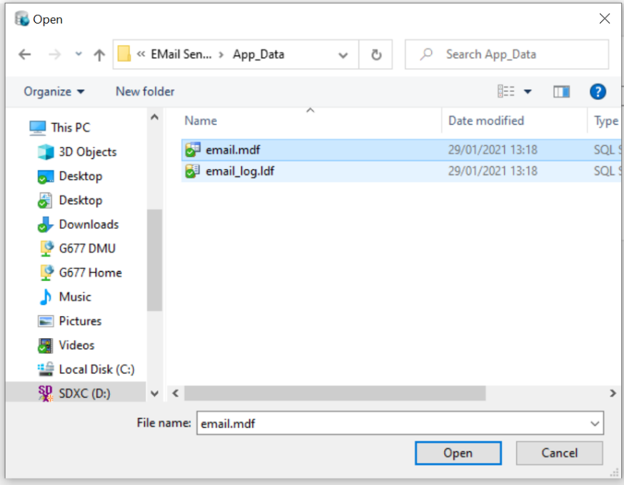

Press ‘Browse’ and navigate to the location of your database file and select the .mdf file then click the Open button.

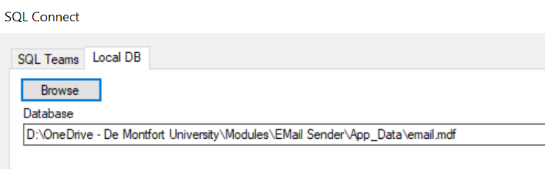

The file path should be listed something like this…

Next click on the ‘Generate connection string’ button. Followed by the ‘Test Connection String’ button. If all is ok you will see the following ‘Connection OK’ message.

If there are issues, check the that you can see the file path where your .mdf file is stored in the connection string by clicking on the link.
If you can’t see the path for your .mdf file in the connection string or if you get a message saying your database is in use or something similar, disconnect from the database from the Server Explorer by right clicking on the database and selecting ‘close connection’ and run SQL Connect again. Don’t forget to reconnect to the database from the Server Explorer.
If you still can’t get the SQL Connect to work, save your work, close down Visual Studio and SQL Connect. Run SQL Connect, reopen your project in Visual Studio and the connect to your database via the Server Explorer.

Creating the Test Record
Even with all of this in place you will still find that your tests are still failing, why?
The problem is that all our tests are looking for a record 21, does such a record exist?
The answer is likely a no!
So, what is the problem?
Clearly, we need to ensure that the test data we are using exists.
Do not carry on to the next section until all your tests are green!

What you need to do
To get your tests working you will need to match up the record ID in the tests to a record that actually exists in your database table.
Set up a new record with test data that matches the test data you are looking for in the same test.
(You will most likely need to change the record ID to whatever Primary Key number is autogenerated for the new record)
Once you have all your tests running green you can be 100% sure that your code for finding records is working perfectly.

Finishing the Find Method

Adding the Find Button to the Presentation Layer
The final test of this functionality is to add a presentation layer to our work.
Previously you will have modified AddressBookDataEntry.aspx to include the following text fields…
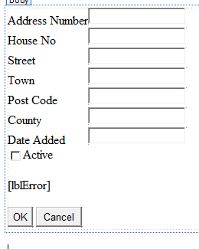
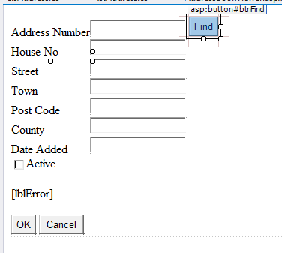

Modify the web form to include a button to execute the find operation…
In this case the button would have an ID of btnFind and the text would be “Find”.

Double click the find button and add the following code…
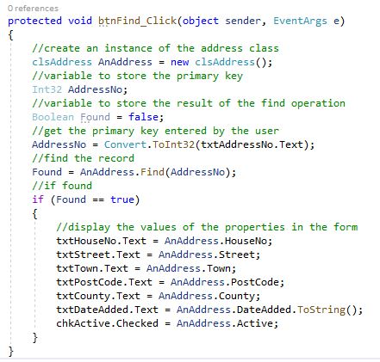

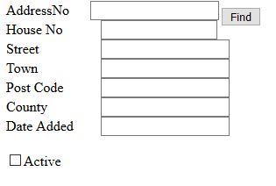
When you run the project, you should see this…

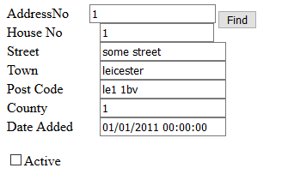

If you enter a valid primary key and click the Find button you should see the data for that record displayed in the text fields…

What you need to do
Add a few more test records to the database and make sure all text fields including the Boolean are populated correctly. For the Boolean you need to add a value of either true or false and the check box will either be checked (if true) or unchecked (if false).

Questions
What happens if you enter a primary key value for a record that doesn’t exist?
How might you fix this to provide an error message?
What happens if you type a text value for the primary key?
Again, what it’s the problem and how might you fix this?

Merge the Branch to the Master
That’s enough work for one GitHub day, remember to merge the code to the master only when you have perfectly working code and delete the branch.

